

Data & Performance Committee

April 20, 2023

*The Data and Performance Committee works to ensure that the CVCoC meets its responsibilities regarding data collection, data sharing and privacy, data quality, implementation of new features, training and recruitment of new Homeless Management Information System participating agencies.*

[04.20.2023 Data & Performance Committee Meeting Presentation](https://www.canva.com/design/DAFgYxTh8Ms/jqklUnxksD4crwgHOdfo7Q/view?utm_content=DAFgYxTh8Ms&utm_campaign=designshare&utm_medium=link&utm_source=homepage_design_menu)

Attendees: Courtney Baldock, Michele Bauman, Angela Davis, Allie Frantz, Sarah Fuentes, Alison Hardy, Jenelle Lambert, Bryan Ottinger, Bethany Tanner, and Kim Towler

1. **Welcome and Introductions**

Sarah Fuentes called the meeting to order at 11:00am by welcoming everyone.

1. **Monthly APR Submissions**

Each month, every HMIS user must submit an Annual Performance Report from HMIS for all of the projects they enter data into. The first few days of the month should be used to complete any remaining data entry. From there, the user should run an initial report to flag errors and start addressing any quality issues flag. By the 25th of every month, each user should have clean data and pull a report to submit to the HMIS Lead, Miriam’s House.

While Sarah Fuentes is out, all reports are due to Sarah Quarantotto for review.

1. **Quarterly Data Quality Report**

The group reviewed the most common, highest error rates for the last quarter’s data quality check. Data entry around income held the highest error rate. These fields are important to track changes and income attainment throughout the time a participant is involved in a program. Sarah reminded the group of how to enter income information, how to update the information, and how to collect it when a client is being closed out.

1. **Annual Reports**
   1. **2023 Point-in-Time Count**

The Point-in-Time Count is a snapshot of the homeless population on a given night required by the Department of Housing and Urban Development (HUD). It is a literal, unduplicated count of all the people experiencing homelessness in our community on a single night (i.e., at a point in time). The count includes sheltered homeless people and unsheltered homeless people. After the data was cleaned up it was submitted to the US Department of Housing and Urban Development on March 20, 2023.

* 1. **2023 Housing Inventory Count**

The Housing Inventory Count (HIC) is a snapshot of the inventory within a CoC dedicated to serve persons who are homeless. The report is intended to provide the Department of Housing and Urban Development (HUD) and CoCs with information about the shelter and housing capacity of the homeless crisis response system. The report was submitted to the US Department of Housing and Urban Development on March 20, 2023.

In the 2023 HIC, emergency shelter capacity decreased by 28% with the Salvation Army’s renovations and the closure of the Hand Up Lodge. In the last 3 years, our community has lost 42% of its emergency shelter capacity.

Permanent housing capacity has remained consistent in the last 3 years. The CoC will continue to focus on expanding permanent housing opportunities. The CoC has the capacity to permanently house 179 people at a single point in time.

* 1. **Longitudinal System Analysis**

Along with the PIT counts and the HIC, the LSA provides the annual HMIS-based data used to write the Annual Homeless Assessment Report (AHAR), a report to the U.S. Congress on the extent and nature of homelessness in the United States.

Looks at how households move through a CoC system in a 365 day span, October 1, 2021 to September 30, 2022.

The report was submitted on January 11, 2023.

* 1. **System Performance Measures**

Required by HUD to measure each CoC's performance as a coordinated system, in addition to analyzing performance by specific project or project types.

Looks at a 365 day span – October 1, 2021 to September 30, 2022. This report is used as a competitive element in HUD's annual CoC Program Competition and to gauge the state of the homeless response system nationally.

The report was submitted to HUD on February 28, 2023.

1. **HMIS Audits in August**

The purpose of accuracy is to ensure that the data in the HMIS is the best possible representation of information provided by the client, as documented by the intake worker.

The purpose of having technical standards is to ensure that all users protect the data in the system correctly.

1. **HMIS User Training**
   1. **Adding Housing Move-in Date for everyone in the household**

A Housing Move-In Date must be recorded for all household members at the point the household moves into a permanent living situation, whether subsidized by the currently enrolled PH project, a different PH project or subsidy, or without any subsidy at all. This may or may not be the same date as Project Exit Date depending on the provision of additional services after the client is housed. Refer to 3.11 Project Exit Date guidance for instructions on Project Exit Date.

* 1. **ROI**

To correct data visibility issues, all HMIS users must add the parent organization in the ROI along with the specific program the client is entering. When you are adding ROI details in the ROI tab of HMIS, be sure to select your parent organization along with the specific program. For example: Roads to Recovery is the parent organization for the Shelter at RESET. The ROI will default to your parent organization (Miriam’s House, Interfaith Outreach Association (IOA), or Roads to Recovery). To add the specific program, select **Search:**

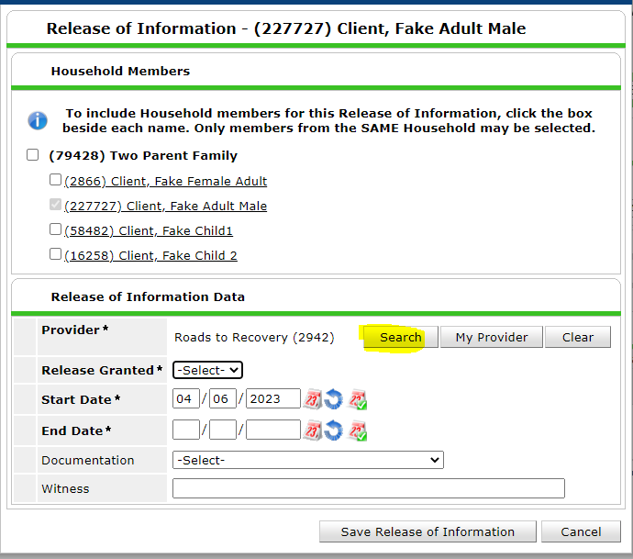

Then select the green plus next to the program you are entering the client into:

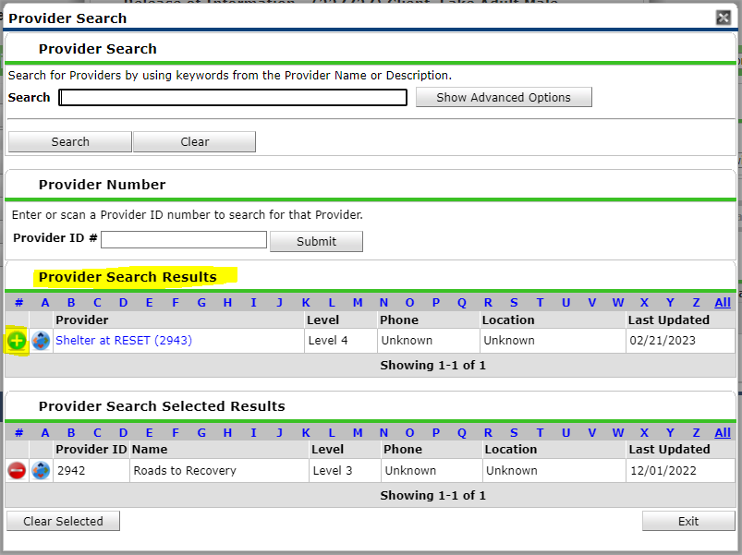

At this point, you should see two providers included in the select results:

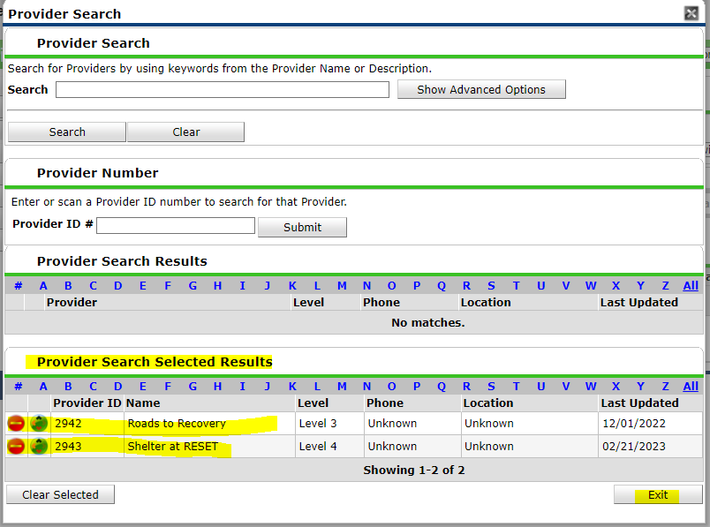

Select **Exit**. You should see both “Providers” on the ROI screen:

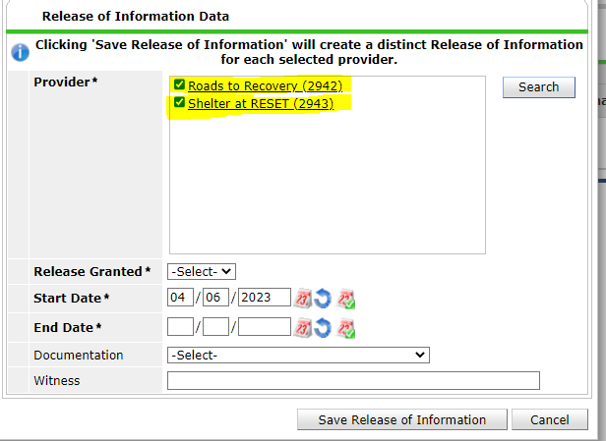

Complete the rest of the information and select **Save Release of Information**.

* 1. **Checking Program Roster**

To check your programs roster, run APR for the current date. To do this, log into HMIS. Select **Reports**, then select **FY2023 CoC APR**. Select your program. Select the calendar icon with the green checkmark next to it as the Program Data Range (for start and end date) to automatically input today’s date:

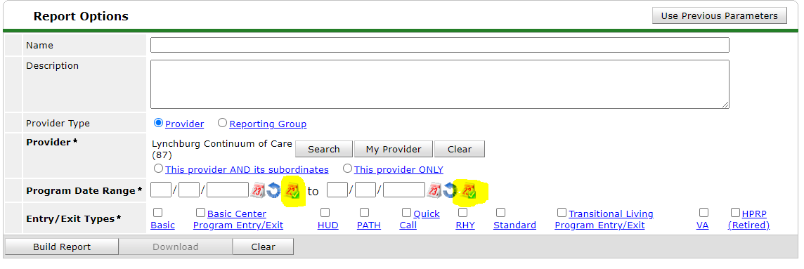

Select **HUD.** Select **Build Report**. This report is now made up of people who are currently enrolled in this program. Use this time to confirm that everyone is there and that there is no one missing.

1. Questions/Announcements
2. Data and Performance Meeting Schedule:
3. Thursday, July 20, 2023 at 10am
4. Thursday, October 19, 2023 at 10am
5. Thursday, January 19, 2024 at 10am

*Meeting minutes were prepared and submitted by Sarah Fuentes, Data & Performance Committee Chair*